Scenic Valley Farms 2023 Chardonnay

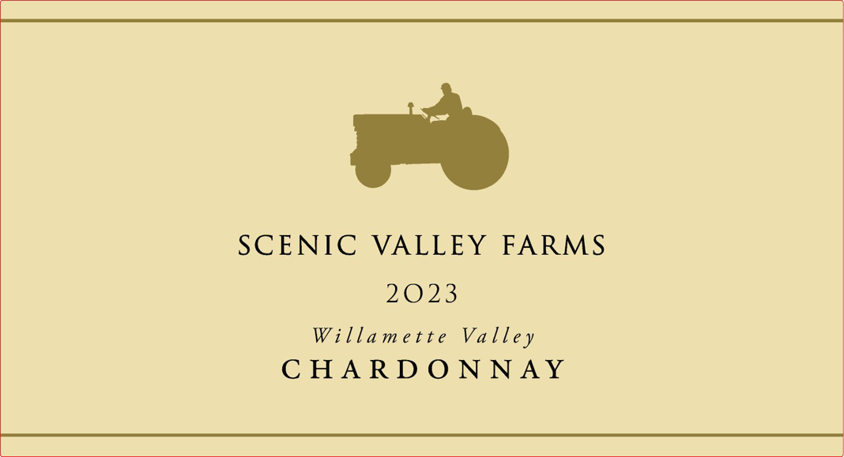
Cases: 400
AVA: Willamette Valley
Technical Data:
pH – 3.30
RS – < 8 g/L
FSO – 15 ppm
Alcohol – 12.3%

Fermentation: 60% wild fermented in barrel, 40% stainless steel, partial ML

Cooperage: 10% new Oregon oak, 50% neutral oak, 40% stainless steel

Vineyards: 35% Coria (South Salem Hills) 25% Kent (Eola-Amity) 40% 45th Parallel (Willamette Valley)

Tasting Notes: A delicate and beautiful Chardonnay. Expressions of apple and peach dance lightly across the palate while a gentle touch of Oregon oak provides structure and depth. A lovely food pairing for fish or vegetable dishes.

Winemaking Notes: Working with some new vineyards for the first time in many years, this Chardonnay was a learning experience. 45th Parallel vineyard gave the wine richness of texture, while the Coria vineyard balanced that with bright acidity, and Kent vineyard gave the wine depth with tropical fruit flavors. The three of them combined, created a beautiful Chardonnay with depth and complexity that is full of flavor but light on its feet.
Vintage Notes: A long cold winter led to a late budbreak at the very end of April, but a heat wave in May allowed the vines to catch up quickly. Sporadic fall rain created a tricky vintage, with dry periods for harvesting grapes mixed with rainy periods that forced us to take a break from harvesting but allowed us to focus on processing the juice in the cellar. As we like to say at Scenic Valley, these long slow harvests are the most difficult, but they make the most interesting wines.

