Scenic Valley Farms 2023 Orchard Block Red Blend

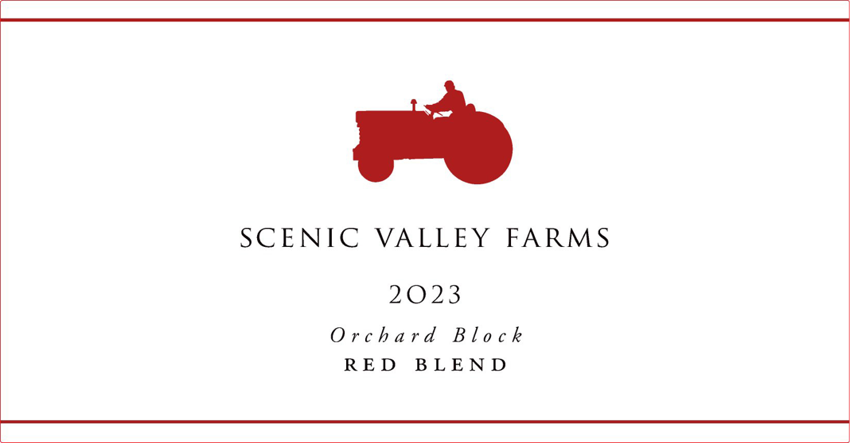
Cases: 141
AVA: Willamette Valley
Technical Data:
pH – 4.40
RS – < 2 g/L
FSO – 24 ppm
Alcohol – 12.1%

Vineyards: 100% Estate vineyard, orchard block

Blend: 70% Tempranillo, 20% Gamay 10% Dolcetto

Fermentation: Harvested between 21.2-23.0 BRIX and wild fermented for 14 days

Cooperage: 6 neutral oak barrels for 8 months
Tasting Notes: Easy drinking and crowd pleasing, this is a great party wine to share with friends, or to drink at home on pizza night.

Winemaking Notes: Our farm was built on deep, rich soils that can grow almost anything. In 2018 we planted some experimental vines where we once had a cherry orchard, including two rows of Dolcetto, two rows of Tempranillo, and two rows of Gamay. While we're still not ready to release these wines as individual varietals, we think the sum is greater than its parts and are happy to release this red blend from our "Orchard Block."
Vintage Notes: A long cold winter led to a late budbreak at the very end of April, but a heat wave in May allowed the vines to catch up quickly. Sporadic fall rain created a tricky vintage, with dry periods for harvesting grapes mixed with rainy periods that forced us to take a break from harvesting but allowed us to focus on processing the juice in the cellar. As we like to say at Scenic Valley, these long slow harvests are the most difficult, but they make the most interesting wines.

